**Alpha Group**

Ashley Landin

Cody Ferre

Deandra Ash

Irene Carrillo Jaramillo

Samuel Segars

**Case Study Project**

**Milestone #1:**

Case Chosen: Bacchus Winery

Business Rules:

Bacchus has multiple Wines

Bacchus has multiple Suppliers

Bacchus has multiple Employees

One Employee has multiple Positions

Multiple Employee’s have multiple Hours

One Supplier has multiple Products

One Supplier has multiple Shipments

Multiple Shipments have One Supply

Multiple Wine’s have multiple Sales

One Distributor has multiple Sales 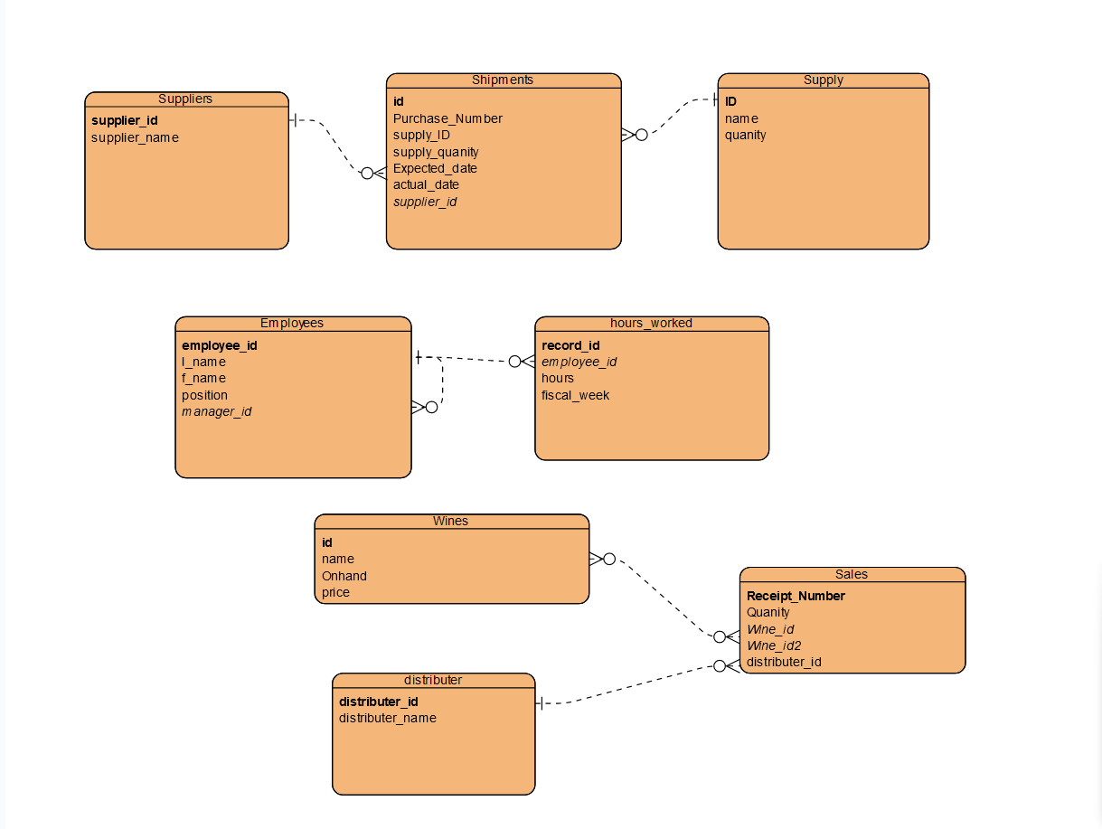

**Milestone #2:**

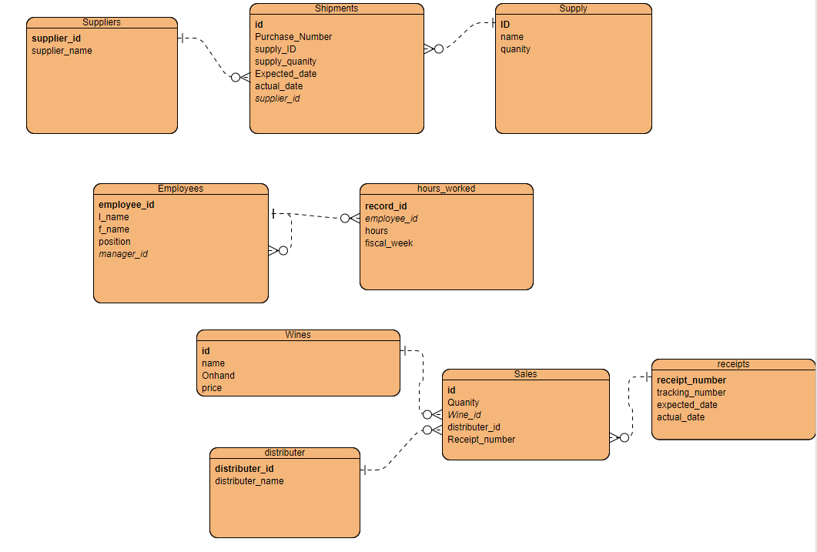

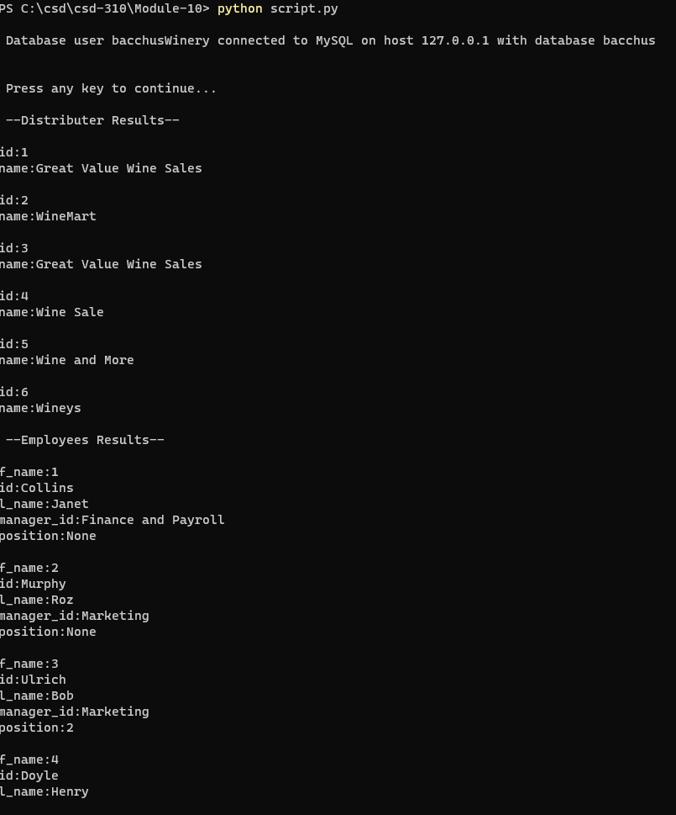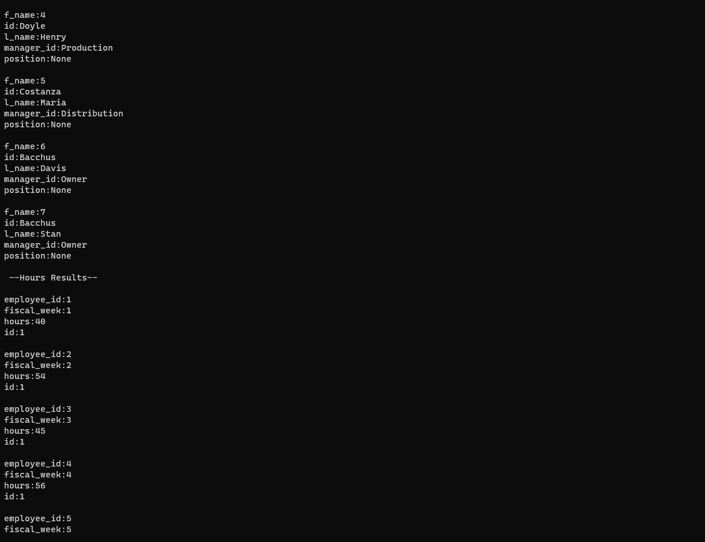

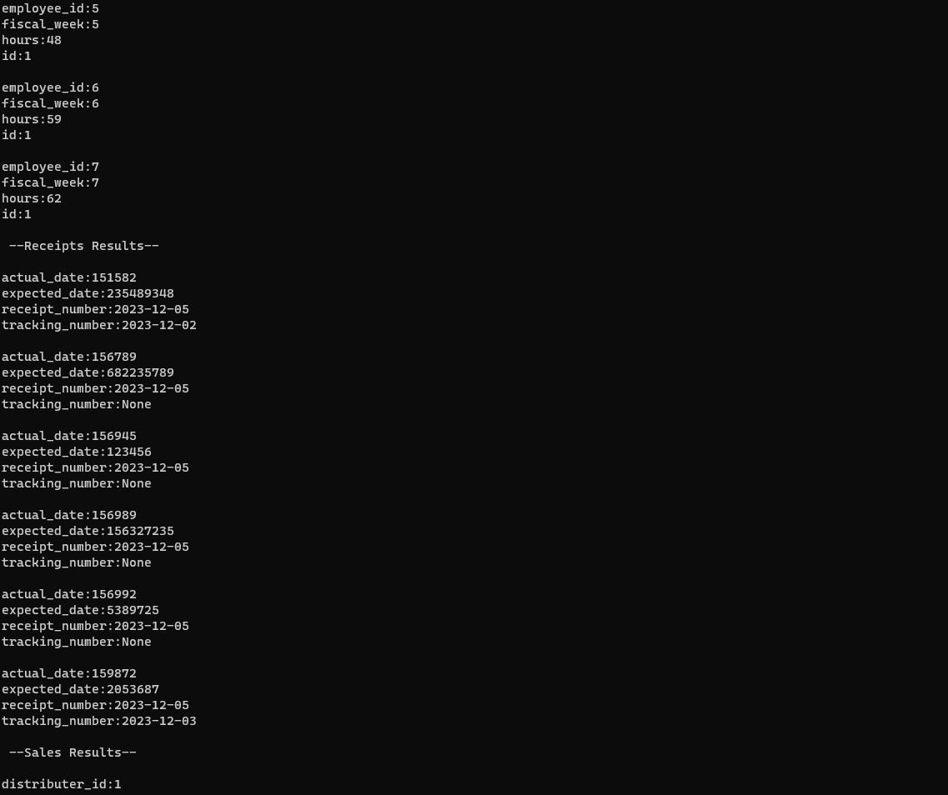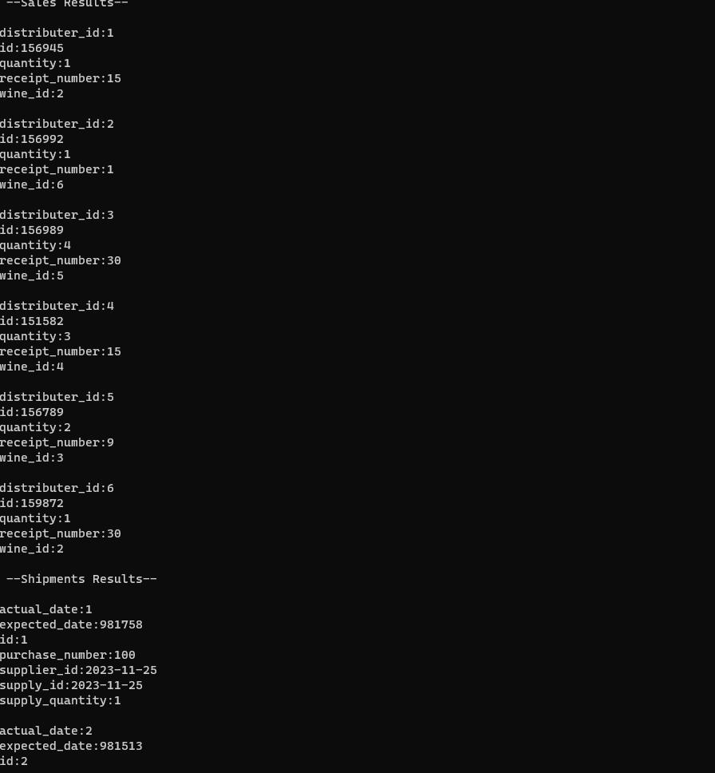

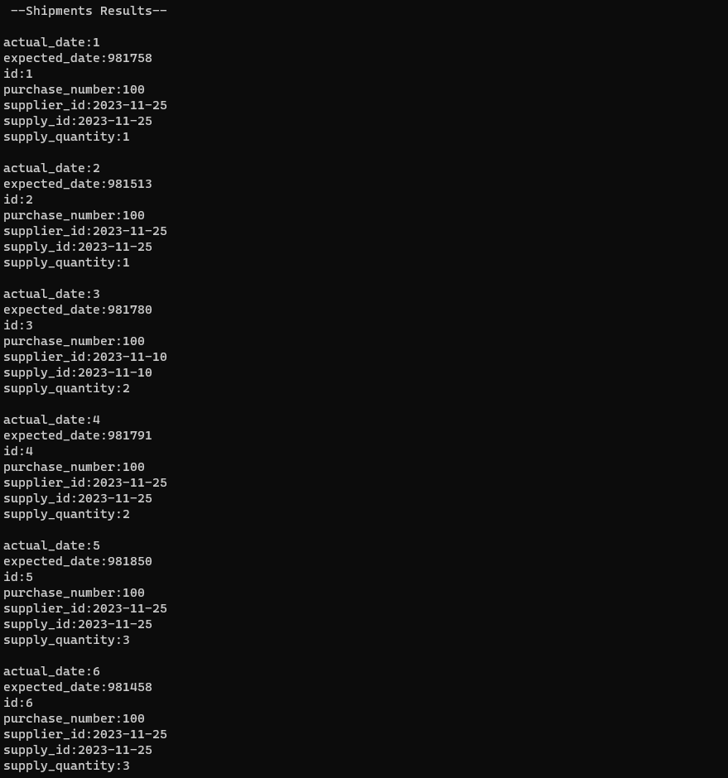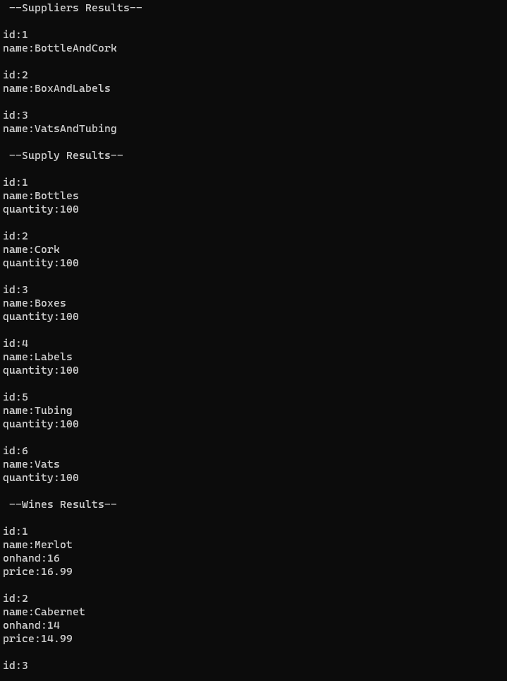

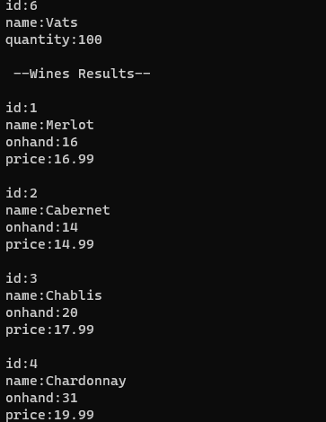

**Milestone #3:**

Reports needed for making the business decisions listed in the case study:

* Question #1: Are all suppliers delivering on time? Is there a large gap between expected delivery and actual delivery? A month by month report should show problem areas.
  + Report on suppliers delivering on time.
  + Report of the suppliers that have large gaps between the expected delivery versus the actual delivery date. Specifically, if the gap is more than a week.
* Question #2: The wine distribution, are all wines selling as they thought? Is one wine not selling? Which distributor carries which wine?
  + Report on wine sales, specifically displaying the trend across the sales of the different wines and noting which ones are selling below average.
  + A report on which distributor carries which wine sold by the winery.
* Question #3: Employee time. During the last four quarters, how many hours did each employee work?
  + A report on the hours each employee worked during the last four quarters.

**Delivery Report**

This report shows us the supplier's name, the expected date of delivery, the actual date of delivery, whether it was on time, and by how many days late the delivery was. From this point we can see that most of the suppliers had a good time ratio when delivering their supplies, however the supplier BoxandLabels had a delivery late by 10 days.

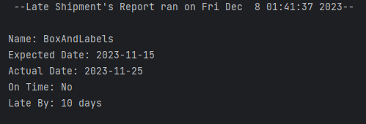

**Wine Distribution Report**

The distribution report shows us what retailer is selling the specific wine, or even if they are selling more than one type of wine. In this case only WineMart is currently selling more than one type of wine with Merlot and Cabernet being the two wines that are sold within more than one location.

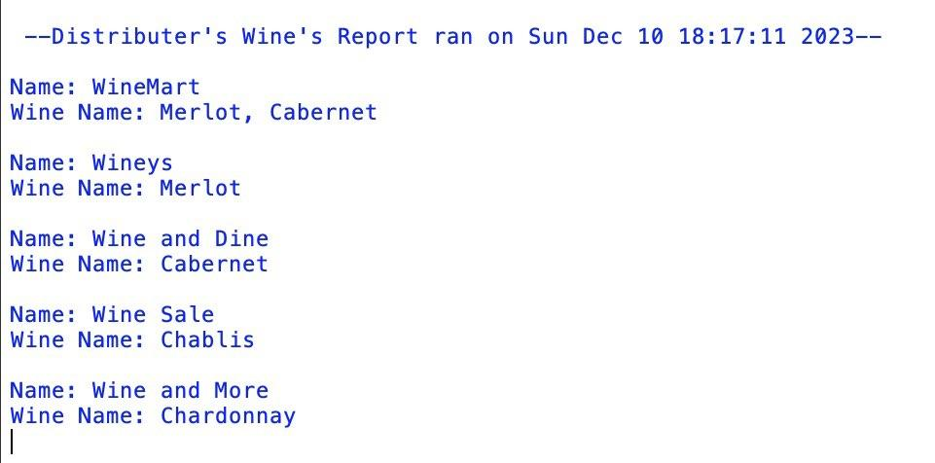

**Wine Sales Report**

The wine sales report pulls the data from the wines table and the sales table, and then calculates the average of the sales for the wines to show how each wine is selling along with whether or not the wine is selling well (above the average) or not selling well (below the average). From the python script being run, we can see that out of all the wines, the Chablis and Cabernet aren’t selling well as they are below the average, and the Merlot and Chardonnay are selling well as they are above the average. The average of the wine sales is displayed below to show as a reference to compare the sales of the wine.

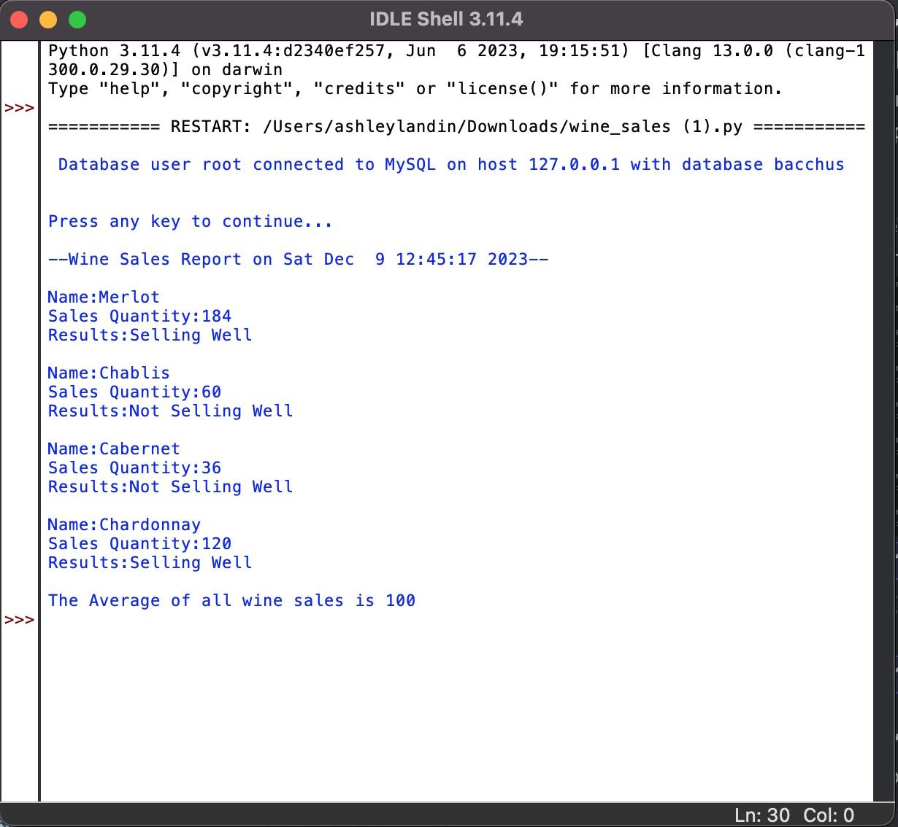

**Employee Hours Report**

The purpose of this report is to inform the current employee’s, their total hours for the last four quarters and show their employee ID. Showing first the employee ID, their name and total hours you can see the trend that certain people are working a crazy amount of time while others are on the lower end and these could be indications of their station as some of the lowest hours are coming from the owner’s Davis and Stan Bacchus along with their head of distribution Maria.

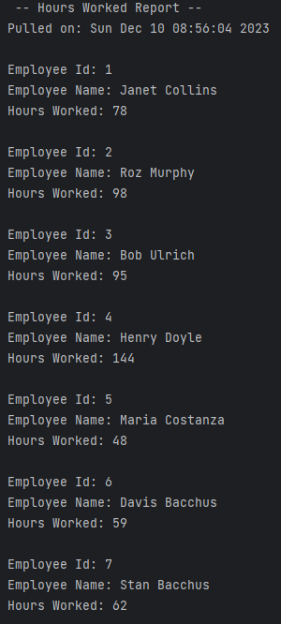

**Milestone #4:**

**Milestone #5:**